**Installation Guide**

**Pre-installation**

Windows 10+

Before installation on windows, users must first install a Linux environment on their system.

Before installation of a Linux environment, users must first enable Windows Subsystem for Linux.

Open the start menu, type “Turn Windows features on or off” and press Enter. In the window that appears, scroll to the bottom and tick “Windows Subsystem for Linux”, and click “OK”. When installation his completed, click “Restart Now”

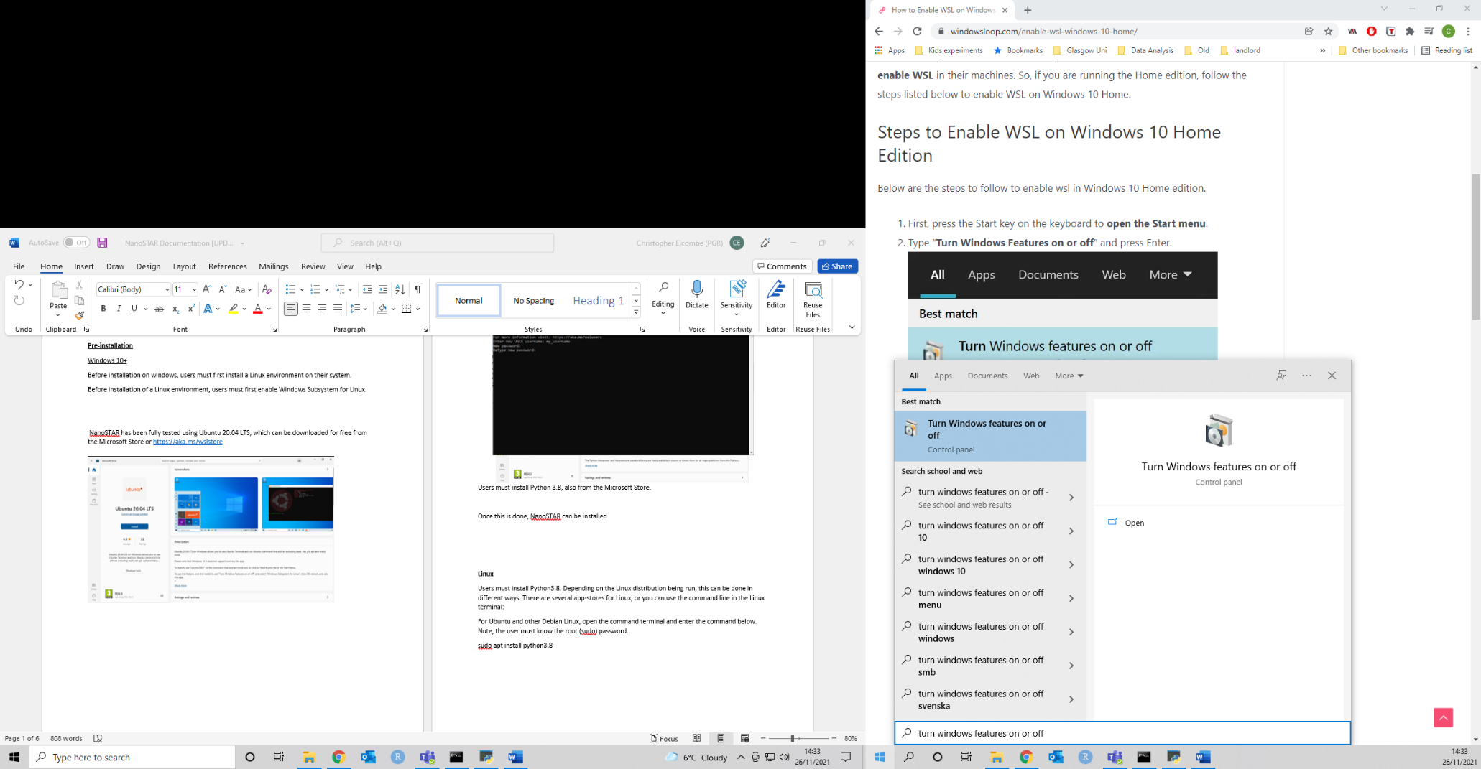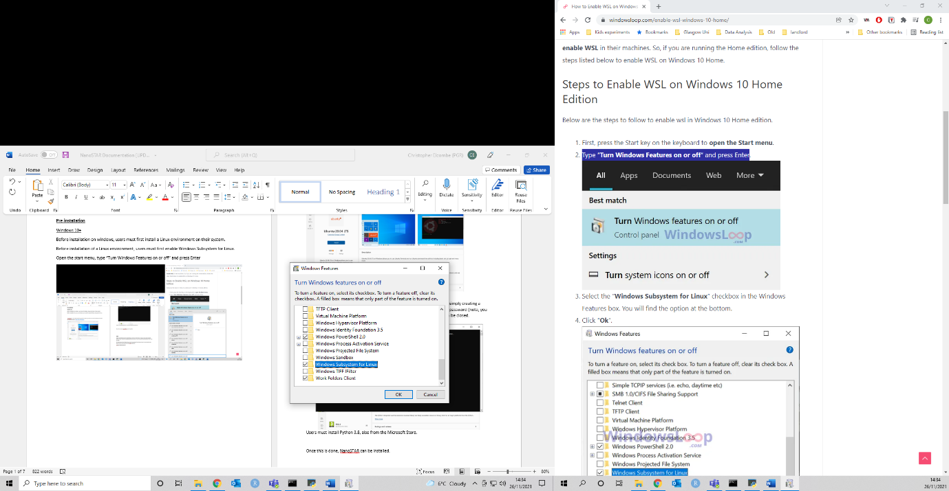

NanoSTAR has been fully tested using Ubuntu 20.04 LTS, which can be downloaded for free from the Microsoft Store or <https://aka.ms/wslstore>

Open Ubuntu to finish the installation, and then set up a user account. This is simply creating a username (allowed characters are lowercase letters, numbers, _ and -), and a password (note, you will not see any characters appear as you type). Once this is done, Ubuntu can be closed.

Users must also install Python 3.8, also from the Microsoft Store.

Once this is done, NanoSTAR can be installed.

**Linux**

Users must install Python3.8. Depending on the Linux distribution being run, this can be done in different ways. There are several app-stores for Linux, or you can use the command line in the Linux terminal:

For Ubuntu and other Debian Linux, open the command terminal and enter the command below. Note, the user must know the root (sudo) password.

sudo apt install python3.8

Once this is done, NanoSTAR can be installed.

**Installation**

Download the zip file from the GitHub repository (<https://github.com/lab-rat-kid/NanoSTAR>) and extract it to your desired location. We recommend doing this into a “lower” directory, for example “C:\NanoSTAR”.

Once files have been extracted, navigate to the folder. For windows users, run the file named “NanoSTAR Win Launcher.cmd”. For linux users, run the NanoSTAR.py You may get a notification asking if you are sure you wish to run the programme as the publisher is unknown. Allow the programme to run and the NanoSTAR user interface will appear.

Click “Install NanoSTAR & Requirements”.

For windows users, in the black Command Prompt window behind the NanoSTAR interface, the installation will begin. The user will need to enter the password used when setting up their Ubuntu user account.

For Linux users a terminal window will appear, and the user will need to enter the root password.

NanoSTAR installation is now complete. Please refer to the User Guide for further details.